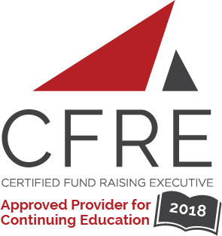
CFRE International has developed this form as a way for you to quickly track (and keep in your files!) the continuing education sessions you have attended. Simply check the boxes next to the sessions you attended. At the end of the conference, add up the total number of hours. Keep this sheet and you will be ready to complete your application form. All of the session slots listed are eligible for continuing education points on your CFRE application for initial certification and/or recertification. Sessions not listed here are not eligible for points.

CONTINUING EDUCATION POINTS TRACKER

Activity Organizer: - ALDE
Title of Activity: - ALDE 2018-2019 Webinars
Names of Presenter(s): - Various
Dates and Location: - Various – Online

Date: 16 August, 2018
12:30 pm – 1:30 pm (1.0 pts)
- The New Tax Law: What It Means for Charitable Giving and What to Suggest to Donors - John Jensen

Date: 20 September, 2018
12:30 pm – 1:30 pm (1.0 pts)
- Igniting Change Without Sparking Disaster - Evan Moilan

Date: 18 October, 2018
12:30 pm – 1:30 pm (1.0 pts)
- Building a Donor Relationship -- With WHOM? - Paul Hanson

Date: 15 November, 2018
12:30 pm – 1:30 pm (1.0 pts)
- IGNITE Giving Through the Bequest of the Future - Glenn Pittsford

Date: 21 February, 2019
12:30 pm – 1:30 pm (1.0 pts)
- If You Confuse, You Lose. Learn How to Create Crystal Clear Communications. - Casey Fuerst
Date: 21 March, 2019
12:30 pm – 1:30 pm (1.0 pts)
- Igniting a Social Media Fire - Ashley Wiehe

Date: 25 April, 2019
12:30 pm – 1:30 pm (1.0 pts)
- Large Shop to Small Shop: Ways to Make it Your Prospect Research Shop – Frank Choi

Date: 16 May, 2019
12:30 pm – 1:30 pm (1.0 pts)
- Leadership Engagement - Rich Duncan

Date: 20 June, 2019
12:30 pm – 1:30 pm (1.0 pts)
- Fan the Flame: Turn a Cold Call into a GOLD Call - Bethany Krepela

Total number of points attained: __________

